**Memory Game application**

Contents

Starting the game 2

Single Player Mode 5

Multiplayer Mode 8

Memory Game Server 9

**Memory Game** application is a single player + multiplayer memory game.

# Starting the game

In order to play the game in any mode, user is required to register through Sign in/Registration window. User must be connected to the internet for registration and login actions.

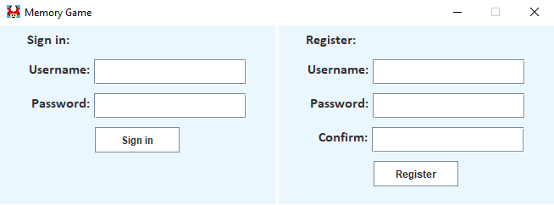

*Picture 1: Sign in/Registration window*

Upon successful registration and login, user will be offered to pick between single player or multiplayer mode through Game Mode window.

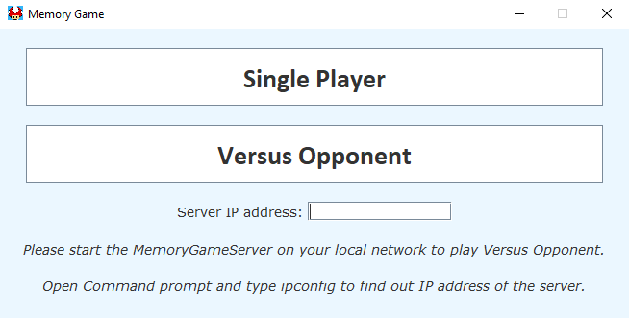

*Picture 2: Game Mode window*

In order to play single player, internet connection is not required, but user won’t be able to access High scores table nor will his Performance score be uploaded to the database upon finishing the game. In other words, user’s scores won’t be saved upon finishing the game if he’s offline. For Single player mode *Server IP Address* field is left blank.

In order to play multiplayer, user must at least be connected to Local Area Network (LAN). Another requirement is that at least one computer on the LAN is running *MemoryGameServer* application – this is the local server. The user who is running the local server on his computer can leave the *Server IP Address* field blank – *MemoryGame* application will automatically connect to the local server running on his computer upon clicking *Versus Opponent*.

Other users on this LAN will have to type in the local IP address of the computer that is running the local server in the *Server IP Address* field. To find out the local IP address of this computer, open Command Prompt on it, type **ipconfig**,press Enter and look for **IPv4 Address**. It is usually in format **xxx.xxx.x.x** where **x** represents a number. Below is an example of how it might look like.

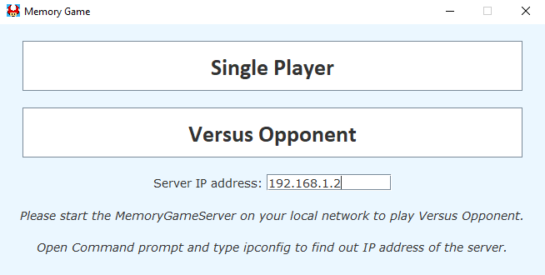

*Picture 3: Example of how entering a local IP address might look like*

If the user wants to play online versus users who are not connected to the same LAN, internet connection is required. After ensuring user is online, he can connect to the global multiplayer server by typing **20.123.184.82 (UPDATE: CURRENTLY OFFLINE)** in the *Server IP Address* field. This will either match him with another user who is waiting for the opponent or it will place him in the empty match waiting for another user to connect to the multiplayer server.

# Single Player Mode

In Single Player mode the goal is to find all the 10 pairs of cards with as minimum tries as possible. Your attempts will be counted and your *Performance score* will be calculated on the end of the game. The time it takes you to find the pairs is not relevant for the final score, only your attempts are taken into consideration. Do not mix *Score* with *Performance score* as these are not the same. *Score* just shows how many pairs you have found – each pair you find increases your *Score* by 10 points. Achieving 100 points ends the game and then your *Performance score* is calculated.

Below is an example of a Single game in progress. User has already found 1 pair and he have one pair opened which doesn’t match. The pairs that do not match are shown for 1,5sec before being hidden again.

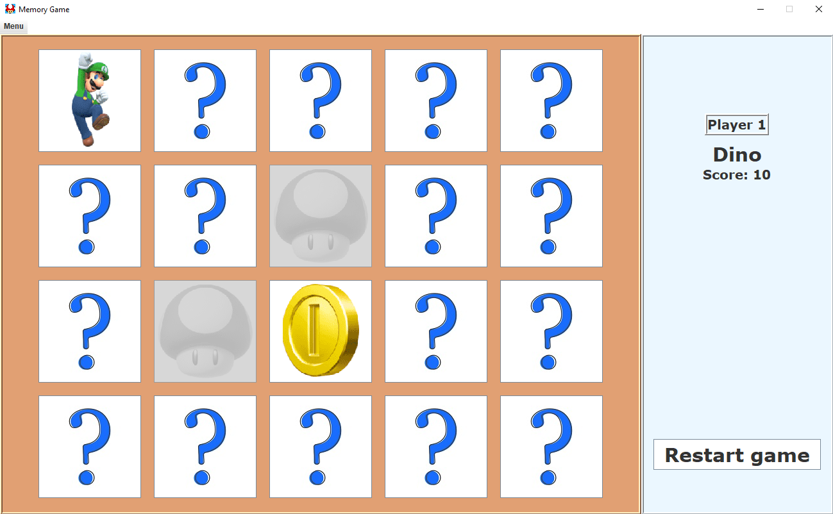

*Picture 4: Example of a Single player game in progress*

A Single player game can be restarted at any moment. Cards will be reshuffled upon restarting the game. Keyboard shortcut for restarting game is Shift + Y.

In Single player mode, upon completing the game, the final Performance score will be saved to user’s *My Scores* table if the user is connected to the internet. User’s scores can be sorted by time or by score in both ascending and descending order for each. To open the *My Scores* table, make sure you are connected to the internet, go to Menu (Alt + Q shortcut) and click *Show my scores* (Shift + D shortcut).

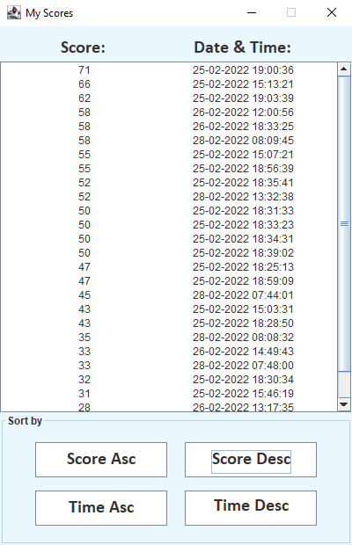

*Picture 5: Example of My Scores table where scores are sorted by score in descending order*

If the user achieves his personal High score, it will be saved to *High Scores* table, assuming user is connected to the internet. High scores of all the registered users who completed at least one game in single player mode while being connected to the internet are saved to this table. To open the *High Scores* table, make sure you are connected to the internet, go to Menu (Alt + Q shortcut) and click *High scores* (Shift + S shortcut).

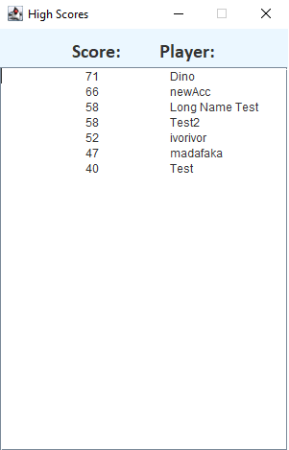

*Picture 6: Example of High Scores table*

Final note on *My Scores* and *High scores*: only results achieved in Single player mode are tracked in these tables. Multiplayer mode is not tracking any results.

# Multiplayer Mode

In multiplayer mode, the goal is to find more pairs than the opponent while playing on the same board with 10 pairs of cards. A player with a higher score after all the pairs have been found is the winner. Note that since there are 10 pairs of cards, it is possible that the outcome of the game is a tie where both players found 5 pairs.

At the start of every game, a player is randomly chosen to play first. There are no exceptions to this rule. Even if the game is a rematch, player is randomly chosen not taking into consideration who was the winner. Rematch can be requested at any time of the match. Note that rematch button will be disabled for 15 seconds upon requesting one in order to prevent spamming the opponent with rematch requests. Cards will be reshuffled upon rematch.

In multiplayer mode, each player can see which pair was opened by the opponent for 1,5sec after the opponent opens his second card. This means that the user can see what was opened only after the opponent opened both cards.

Below is an example of a multiplayer game in progress where each player found one pair.

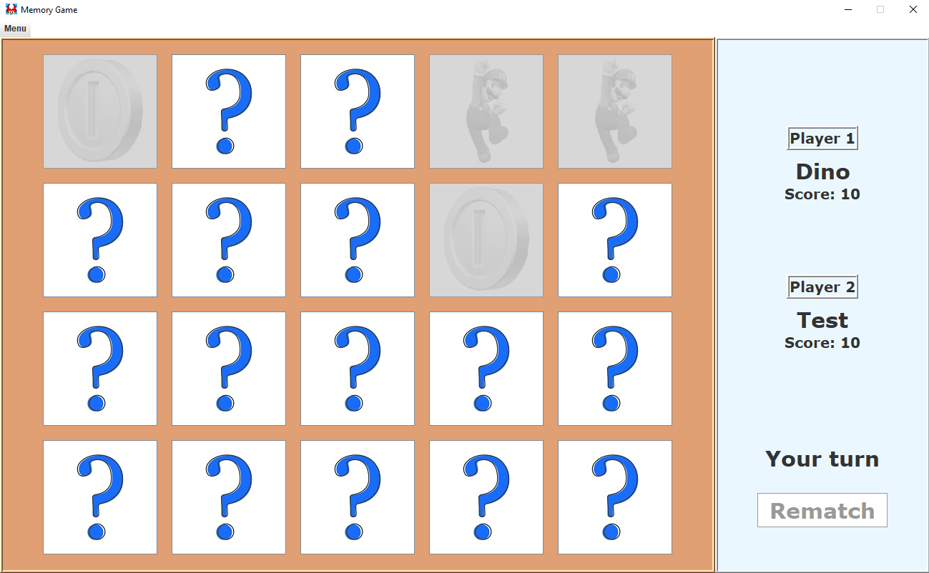

*Picture 7: Example of a multiplayer match in progress*

# Memory Game Server

Memory Game server can be used on the Local Area Network to play multiplayer with users on the network if you don’t have an internet connection. It has 10 Game Rooms – each room is used to host one match at the time. This means Memory Game server can hold up to 20 users at the time. The server displays info about each room in real time – whenever someone joins or leaves any room, it will be displayed immediately in Memory Game Server window.

Below is an example of Memory Game Server window where the server is hosting one match with 2 players.

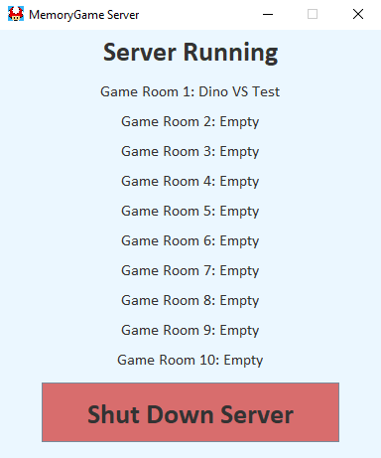

*Picture 8: Example of a Memory Game Server window*